**PMSM DRIVE REPORT File name: pmsm_drive_1.slx**

**Serhat ÖZKÜÇÜK pmsm_drive_2.slx**

--------------------------------------------------------------------------------------------------------------------------------------

**DYNAMİC MODEL OF PMSM**

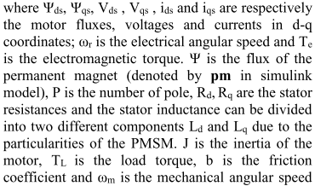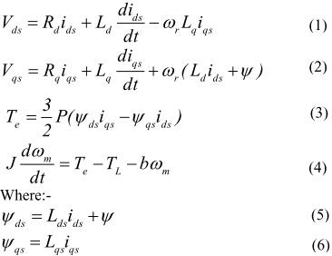

**PMSM_DRIVE_1.SLX IS DESIGNED BASED ON HYSTERESIS CURRENT CONTROLLER (SEE FIG 1).** 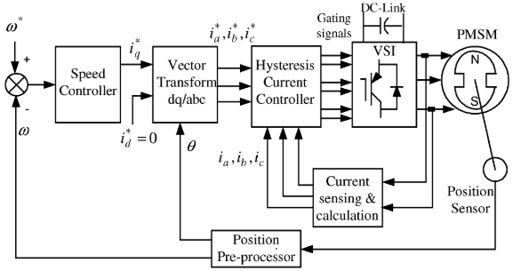 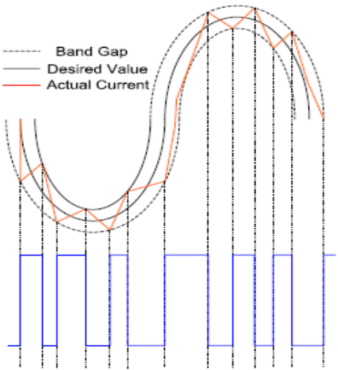Fig.1: Hysteresis current controller block diagram – Hysteresis current controller inverter gate signals

**Pmsm_drive_1.slx Model & Results**

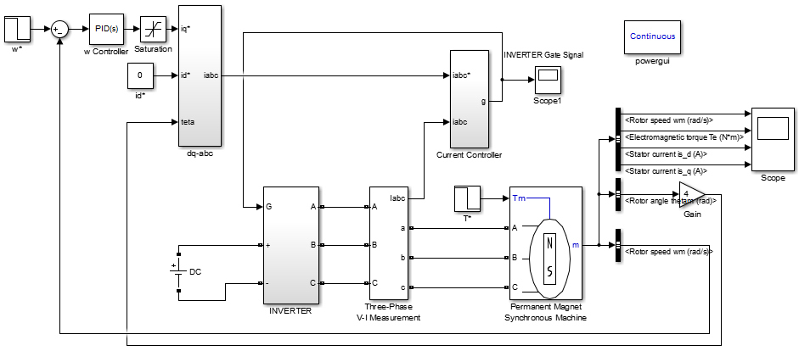

w* reference speed is given to system (100 to -100 @0.5s). A PI controller (PID block: P:1.25 I:1 D:0) calculates iq* from w-w* error. İd* is set as 0. Teta is measured from PMSM machine. iabc is calculated by dq to abc and is send to controller.

$$ia=iqcosθ-idsinθ$$

$$ib=iqcos\left(θ-\frac{2π}{3}\right)-idsin\left(θ-\frac{2π}{3}\right)$$

$$ic=iqcos\left(θ+\frac{2π}{3}\right)-idsin\left(θ+\frac{2π}{3}\right)$$

Second input of controller is measured iabc. Controller works according to Fig.1 hysteresis control technique and creates gate signals for inverter. Inverter (switches 400V DC sources for creating 3ph AC) creates AC phases and drives the PMSM machine. Speed reference w* is changed from 100 to -100 @0.5th second. Torque reference T* is changed from -10 to 10 @0.5th second because keeping the machine at constant torque.

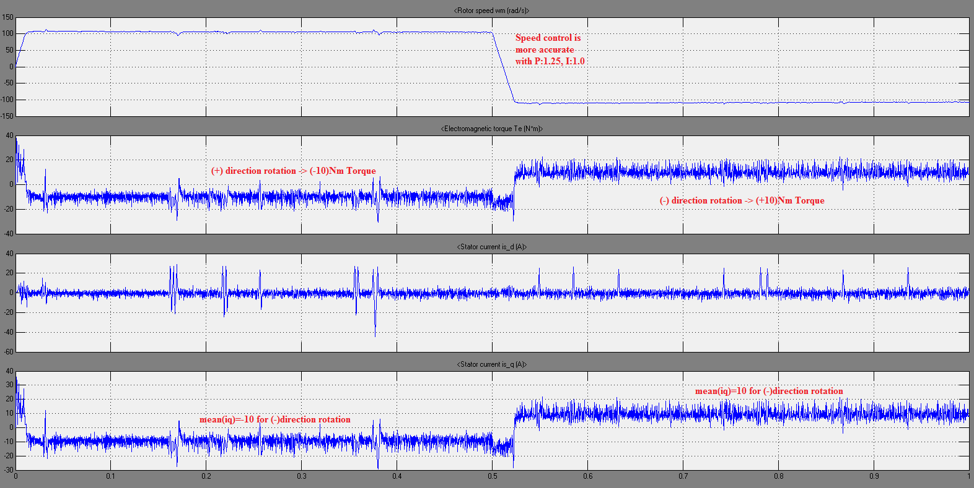(P:1.25, I:1.0, Load Torque Tm:10Nm is constant for all rotation direction)

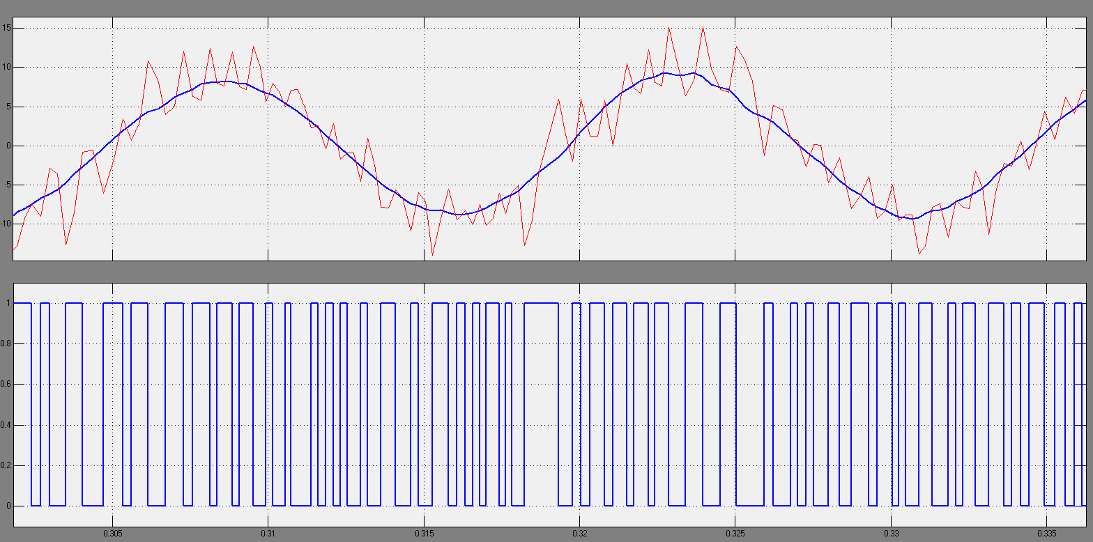Hysteresis current controller-Gate signals. (Blue : Desired Current, Red: Actual Current, Band: ~4A)

**-------------------------------------------------------------------------------------------------------------------------------------**

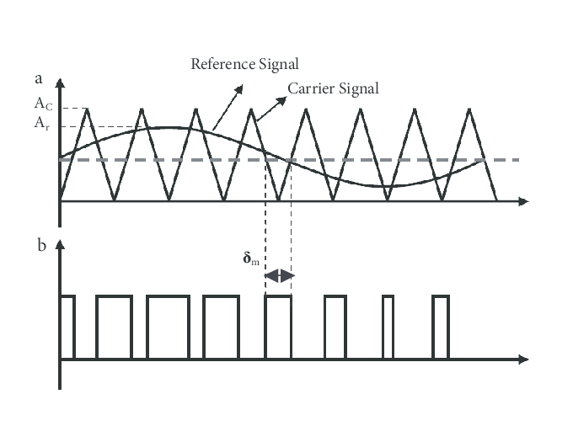**PMSM_DRIVE_2.SLX IS DESIGNED BASED ON SINE PWM VECTOR CONTROL BELOW.**

The most basic and straight forward PWM strategy

is the Sinusoidal PWM. This method is used specially

for loads with neutral tied to the ground or

the DC mid-point.

The maximum value of A is Amax=Vdc/2

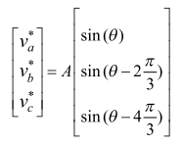

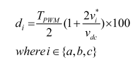

**Pmsm_drive_2.slx Model & Results**

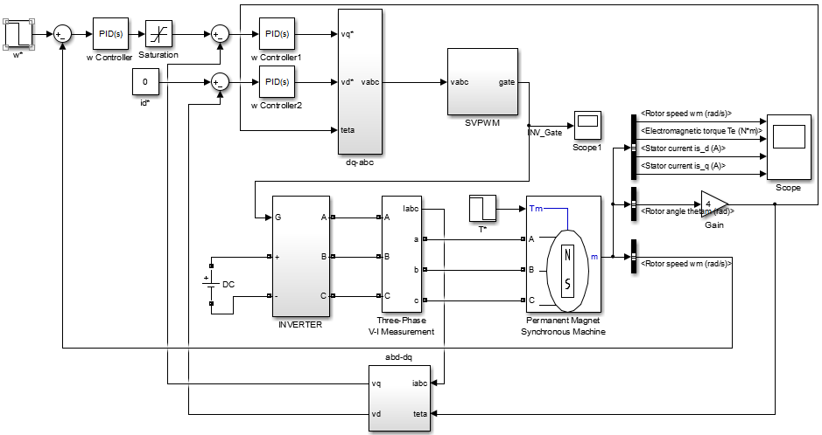

w* reference speed is given to system. A PI controller (PID block: P:1000 I:5 D:0) calculates vq* from w-w* and vq*-vq error. İd* is set as 0. Teta is measured from PMSM machine. vabc is calculated by dq to abc and is send to PWM generator. The carrier wave (Triangular block in SVPWM – 5kHz) comparison method is used to generate a PWM pulse.

$$vq=2/3[vacos\left(θ\right)+vbcos\left(θ-\frac{2π}{3}\right)+vccos(θ+\frac{2π}{3})$$

$$vd=-2/3[vasin\left(θ\right)+vbsin\left(θ-\frac{2π}{3}\right)+vcsin(θ+\frac{2π}{3})$$

Inverter (switches 400V DC sources for creating 3ph AC) creates AC phases and drives the PMSM machine. Speed reference w* is changed from 100 to -100 @2nd second. Torque reference T* is changed from 10 to -10 @3rd second.

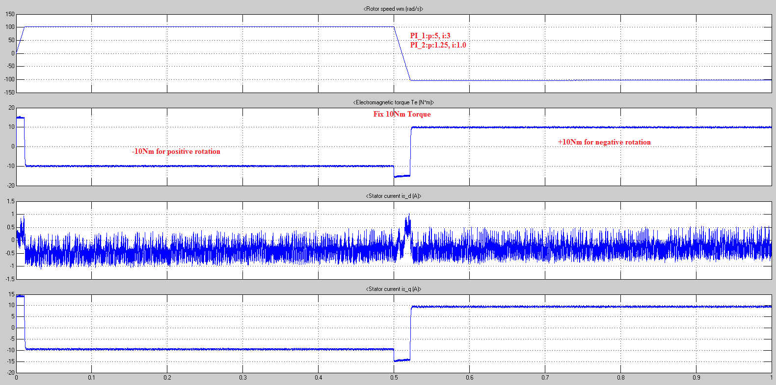zero-crossing control disable

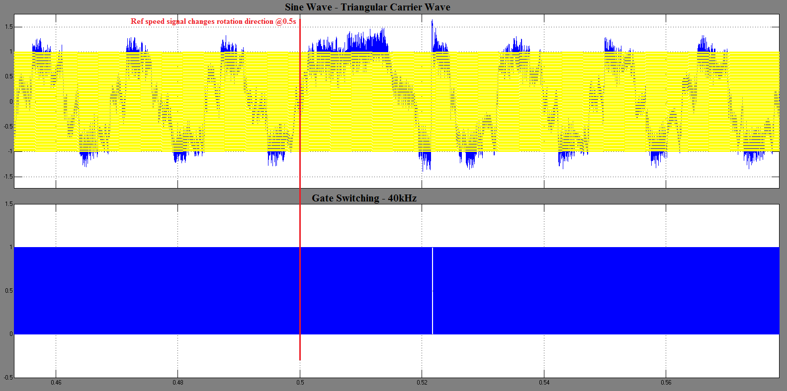

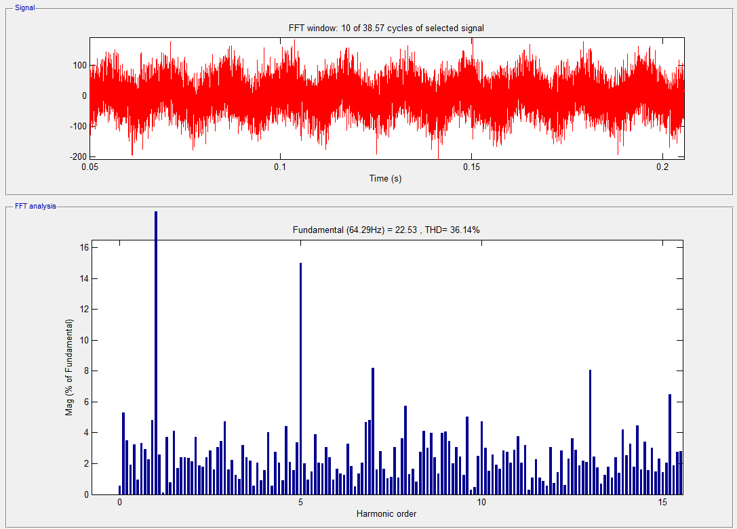

--------------------------------------------------------------------------------------------------------------------------------------

**PMSM_DRIVE_3.SLX IS DESIGNED BASED ON SPACE VECTOR PWM VECTOR CONTROL BELOW.**

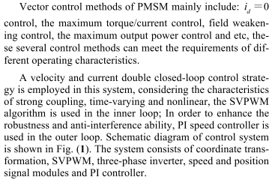 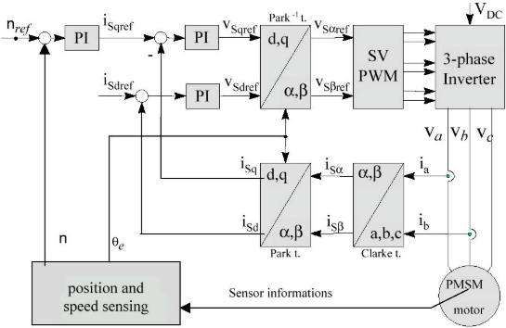

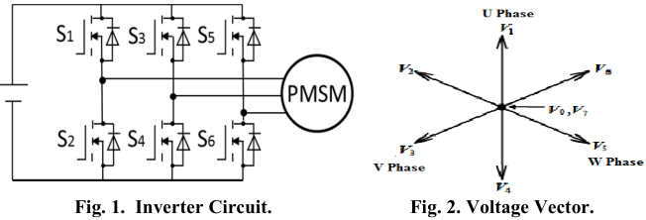 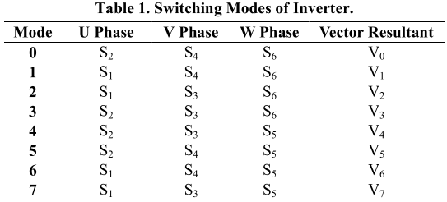

The carrier wave (Triangular block in SinePWM) comparison method is used to generate a PWM pulse.

**Pmsm_drive_2.slx Model & Results**

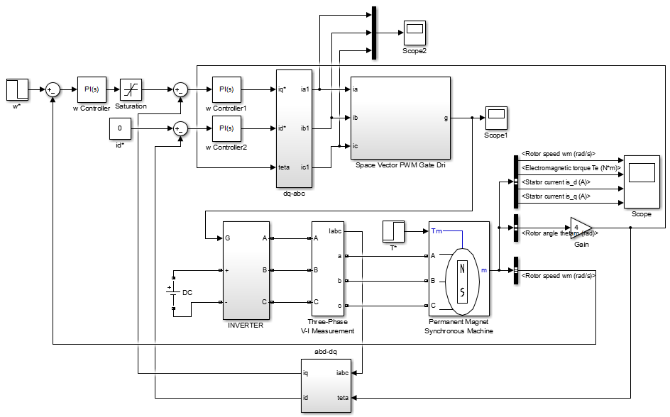

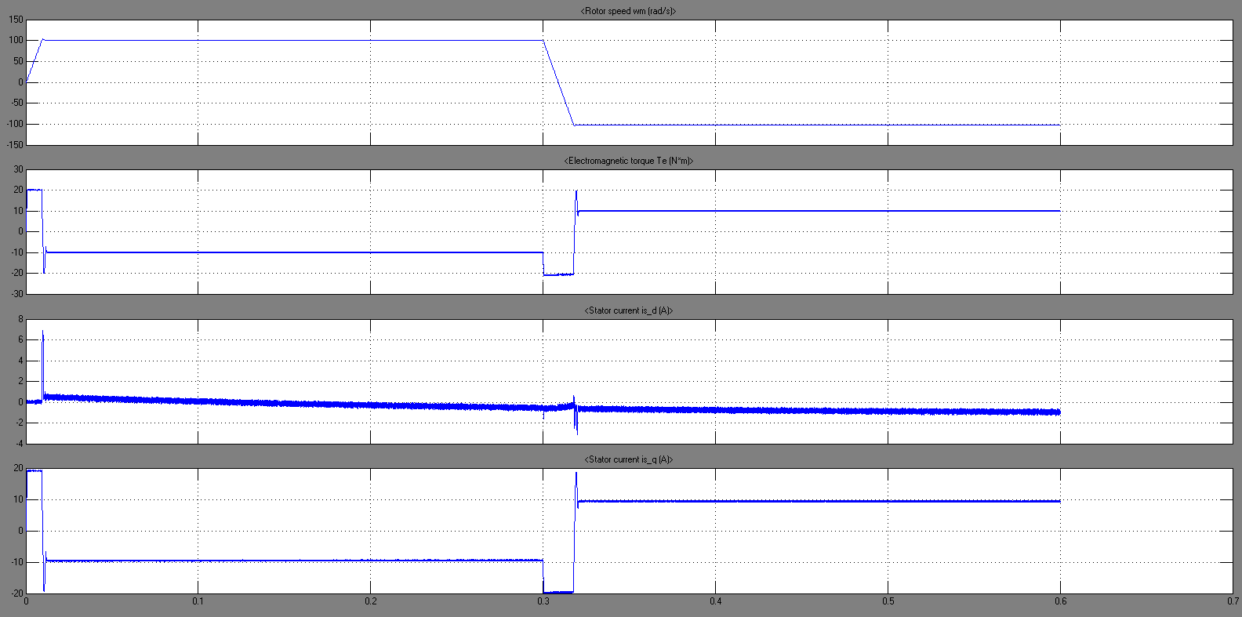

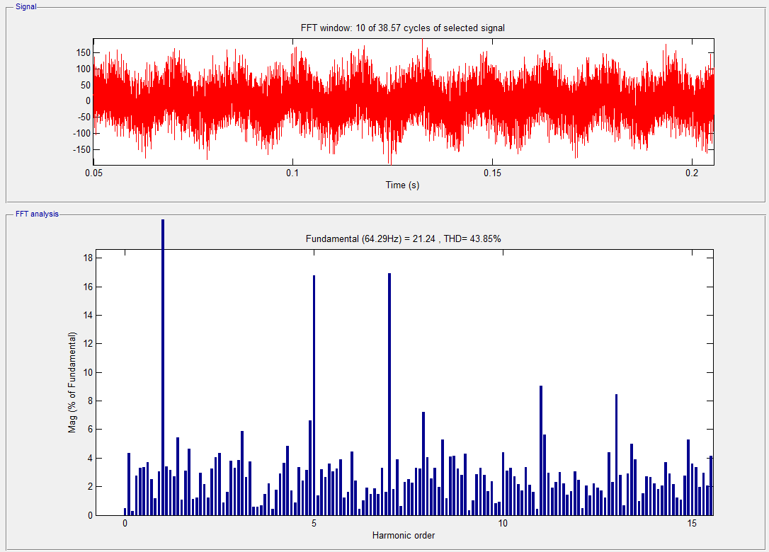

References [1–4]:

[1] Daud AK, Basim A, Zaidan A. DSP based speed control of the surface mounted permanent magnet synchronous motor with hysteresis current controller. Recent Res Syst Sci - Proc 15th WSEAS Int Conf Syst Part 15th WSEAS CSCC Multiconference 2011:214–9.

[2] Liu T, Chen G, Li S. Application of vector control technology for PMSM used in electric vehicles. Open Autom Control Syst J 2015;6:1334–41.

[3] Harahap CR, Saito R, Yamada H, Hanamoto T. Speed control of permanent magnet synchronous motor using fpga for high frequency sic mosfet inverter. J Eng Sci Technol 2014;9:11–20.

[4] Liu Y, Zhang Z. PMSM Control System Research Based on Vector Control 2015:394–7. doi:10.2991/icismme-15.2015.78.